**GET PRODUCTION READY WITH SPRING BOOT – 2 – CONFIGURATION_PROPERTIES**

**application.properties**

logging.level.org.springframework=debug

spring.profiles.active=dev

currency-service.url = http://default1.naveen.com

currency-service.username = defaultusername

currency-service.key = defaultkey

**application-dev.properties**

logging.level.org.springframework=trace

**CurrencyServiceConfiguration.java**

package com.naveen.springBoot.ConfigurationPropertyExample;

import org.springframework.boot.context.properties.ConfigurationProperties;

import org.springframework.stereotype.Component;

@ConfigurationProperties(prefix = "currency-service")

@Component

public class CurrencyServiceConfiguration {

    private String url;

    private String username;

    private String key;

    public String getUrl() {

        return url;

    }

    public void setUrl(String url) {

        this.url = url;

    }

    public String getUsername() {

        return username;

    }

    public void setUsername(String username) {

        this.username = username;

    }

    public String getKey() {

        return key;

    }

    public void setKey(String key) {

        this.key = key;

    }

}

**CourseController.java**

package com.naveen.springBoot.ConfigurationPropertyExample;

import org.springframework.beans.factory.annotation.Autowired;

import org.springframework.web.bind.annotation.RequestMapping;

import org.springframework.web.bind.annotation.RestController;

@RestController

public class CourseController {

    @Autowired

    private CurrencyServiceConfiguration configuration;

    @RequestMapping("/currency-configuration")

    public CurrencyServiceConfiguration retrieveAllCourses(){

        return configuration;

    }

}

**ConfigurationPropertiesApp.java**

package com.naveen.springBoot.ConfigurationPropertyExample;

import org.springframework.boot.SpringApplication;

import org.springframework.boot.autoconfigure.SpringBootApplication;

@SpringBootApplication

public class ConfigurationPropertiesApp {

    public static void main(String[] args) {

        SpringApplication.run(ConfigurationPropertiesApp.class, args);

    }

}

**OUTPUT:**

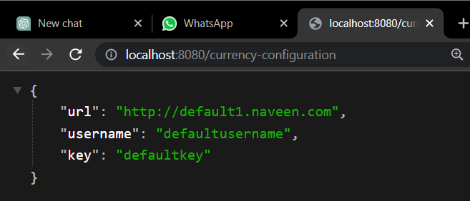

**application-dev.properties**

logging.level.org.springframework=trace

currency-service.url = http://dev.naveen.com

currency-service.username = devusername

currency-service.key = devkey

**OUTPUT:**